Architecture Design Assignment Report
Problem Statement 16 – Smart Mining Operations and Safety Management Platform
Course Code: | CSA1007 | Course Title: | Software Engineering
CO Assessed: | CO2 | Assessment: | AT2 – Architecture Design
Student Name: | Jahnavi Maddi | Reg. No.: | 192411196
Assigned Problem: | Problem 16 | Duration: | 60 minutes

1. Introduction and Problem Overview
Mining operations take place in hazardous, remote, and constantly changing environments where worker safety, equipment reliability, and rapid emergency response are critical concerns. The objective of this project is to design a Smart Mining Operations and Safety Management Platform that continuously tracks the location of workers underground and on-site, monitors environmental conditions such as gas concentration and temperature, detects safety hazards in real time, predicts equipment failures before they occur, coordinates emergency response when incidents happen, and generates safety compliance reports for management and regulatory bodies. The expected outcomes of the system are improved worker safety, reduced accident rates, faster emergency response times, lower equipment downtime, and better overall operational visibility for mine management.

2. Analysis of System Requirements
2.1 System Objectives
- Continuously track the real-time location of every worker across the mining site, including underground zones.
- Monitor environmental parameters (toxic gas levels, temperature, humidity, dust concentration, ventilation) at multiple checkpoints.
- Automatically detect hazardous conditions and unsafe worker behaviour, and raise alerts before incidents occur.
- Analyse equipment sensor data to predict failures and schedule preventive maintenance.
- Coordinate a fast, well-informed emergency response when an incident is detected.
- Generate safety and compliance reports for supervisors, management, and regulators.
2.2 Functional Requirements
- The system shall capture and update worker location data at short, regular intervals using wearable trackers.
- The system shall collect environmental sensor readings continuously from fixed and mobile sensor nodes.
- The system shall apply rule-based and machine-learning logic to detect hazards (gas leak, fire, structural risk, unsafe zone entry) and trigger alerts.
- The system shall analyse equipment vibration, temperature, and usage data to predict likely failures.
- The system shall notify control-room staff, on-site supervisors, and emergency services automatically when a critical event is detected.
- The system shall provide a dashboard for control-room staff and a mobile app for field workers and responders.
- The system shall generate periodic and on-demand safety and incident reports.
2.3 Non-Functional Requirements and Quality Attributes
- Scalability: the platform must support an increasing number of workers, sensors, and mining sites without redesign.
- Reliability: hazard detection and alerting must function correctly even under network or partial system failure, since lives are at stake.
- Availability: the system must operate near-continuously (24x7), as mining operations run in shifts.
- Performance: hazard detection and emergency alerts must be generated within seconds of a triggering event (low latency).
- Security: worker location data, environmental data, and communication channels must be protected from unauthorised access or tampering.
- Maintainability: individual functions (location tracking, hazard detection, predictive maintenance) should be updatable independently as sensors and regulations evolve.

3. Selected Software Architecture
3.1 Chosen Architectural Style
A Hybrid Architecture combining an Event-Driven Architecture (EDA) with a Microservices Architecture, supported by an Edge Computing layer, is selected for this system.
3.2 Justification
Mining safety data originates from thousands of continuously streaming sensor and location events, and several of these events (a gas leak, a fall, a fire) require an immediate, asynchronous reaction rather than a request-response cycle. An event-driven backbone (using a message/event broker) is therefore the natural fit for propagating sensor readings and hazard alerts to every interested service the moment they occur, without tight coupling between producers and consumers.
At the same time, the platform performs several distinct business capabilities — location tracking, environmental monitoring, hazard detection, predictive maintenance, emergency coordination, and reporting — that have different scaling needs, different update frequencies, and different technology requirements (for example, predictive maintenance relies on machine-learning models while reporting relies on batch aggregation). Microservices allow each capability to be developed, deployed, scaled, and maintained independently, which matches the Maintainability and Scalability requirements identified above.
Finally, because mining sites, especially underground zones, frequently have unreliable connectivity to central servers, an Edge Computing layer is added so that time-critical hazard detection (e.g., dangerous gas levels) can be evaluated locally at the gateway even if the link to the cloud is temporarily lost, and only summarised or urgent events are forwarded onward. This hybrid combination directly supports the Reliability and Availability requirements in a way that a single monolithic or purely centralised client-server design could not.

4. Software Architecture Diagram
The diagram below illustrates the overall structure of the proposed system, organised as a stack of layers from field-level sensing to end-user presentation, connected through an edge gateway, a communication network, and a central event bus.
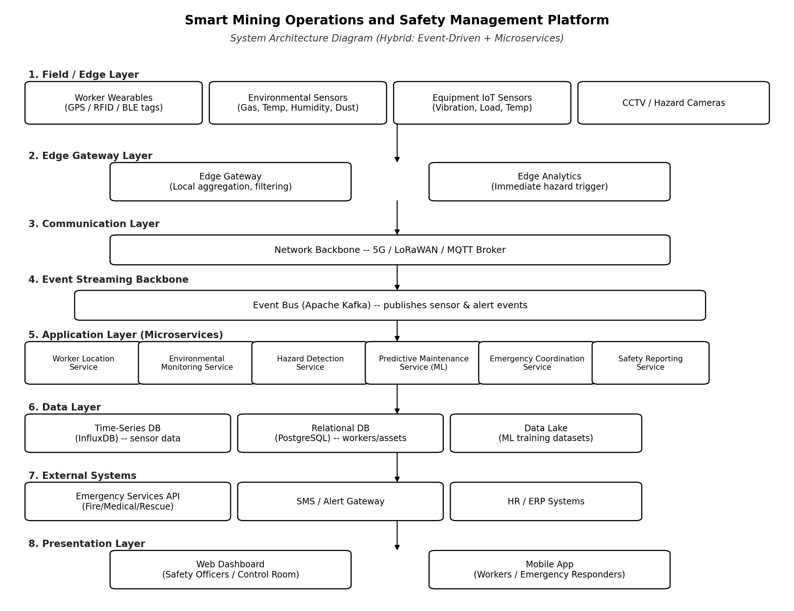

5. Components and Their Interactions
5.1 Field / Edge Layer
Worker wearables (GPS/RFID/BLE tags), environmental sensors, equipment IoT sensors, and CCTV/hazard cameras form the sensing layer. They continuously generate raw location, environmental, and equipment-condition data at the point of activity.
5.2 Edge Gateway Layer
Edge gateways installed at the mine site aggregate and filter data from nearby sensors, and run lightweight edge analytics so that obviously dangerous readings (for example, a gas concentration above a critical threshold) can trigger a local alert immediately, even before the data reaches the cloud.
5.3 Communication Layer
A network backbone using 5G, LoRaWAN, and an MQTT broker carries data from edge gateways to the central platform, chosen for their suitability to low-power, wide-area, and often harsh underground conditions.
5.4 Event Streaming Backbone
An event bus (such as Apache Kafka) receives all sensor and alert events and publishes them to every microservice that needs them, decoupling data producers from consumers and allowing new services to be added later without modifying existing ones.
5.5 Application Layer (Microservices)
- Worker Location Service – maintains real-time and historical positions of every worker and checks for unsafe-zone entry.
- Environmental Monitoring Service – tracks gas, temperature, humidity, and dust readings against safe thresholds.
- Hazard Detection Service – correlates location, environmental, and camera data to identify hazardous situations and raise alerts.
- Predictive Maintenance Service – applies machine-learning models to equipment sensor data to forecast failures and recommend maintenance.
- Emergency Coordination Service – manages incident workflows, notifies responders, and tracks response status.
- Safety Reporting Service – aggregates data from all other services to produce compliance and management reports.
5.6 Data Layer
A time-series database (such as InfluxDB) stores high-frequency sensor data, a relational database (such as PostgreSQL) stores structured records of workers, equipment, and incidents, and a data lake stores historical data used to train and refine predictive-maintenance models.
5.7 External Systems and Presentation Layer
The platform integrates with external emergency services APIs, an SMS/alert gateway, and HR/ERP systems for workforce data. Control-room staff and supervisors interact with the system through a web dashboard, while field workers and emergency responders use a mobile application, both of which subscribe to real-time updates from the relevant microservices.

6. Discussion of Quality Attributes
Quality Attribute | How the Architecture Addresses It
Scalability | Each microservice and the event bus can be scaled independently (e.g., adding more Hazard Detection instances during peak shifts) without affecting other services.
Security | Edge gateways and the communication layer use encrypted channels (TLS/VPN); access to services and dashboards is controlled through authentication and role-based authorisation.
Performance | Edge analytics evaluate time-critical conditions locally, and the event-driven backbone delivers alerts to services and users within seconds instead of waiting for periodic polling.
Reliability | Loose coupling through the event bus means the failure of one microservice (e.g., Reporting) does not stop hazard detection or emergency coordination from functioning.
Maintainability | Microservices can be updated, redeployed, or replaced individually as sensors, regulations, or ML models evolve, without redeploying the entire system.
Availability | Edge-level processing allows core safety functions to keep working during temporary loss of connectivity to the central cloud, and services can be replicated across zones/sites.

7. Justification of Architectural Decisions
7.1 Rationale
The combination of edge computing, event-driven communication, and microservices was chosen because mining safety is fundamentally about reacting quickly and reliably to continuous streams of sensor data under conditions of unreliable connectivity — requirements that a single centralised or monolithic system would struggle to meet. Splitting the system into independent services also reflects the natural separation of responsibilities in the problem statement itself (tracking, monitoring, hazard detection, maintenance, emergency response, and reporting).
7.2 Trade-offs Considered
- Microservices introduce operational complexity (deployment, monitoring, inter-service communication) compared to a monolith, but this is accepted in exchange for independent scalability and fault isolation, which are critical for a life-safety system.
- Edge processing adds hardware cost at each gateway, but is justified because it enables local hazard detection even when the network link to the cloud is down.
- An event-driven design is harder to test and trace end-to-end than a simple request-response design, but it is necessary to support real-time, many-to-many notification of hazards across services and users.
7.3 Support for Future Enhancements
The chosen architecture supports future growth in several ways. New sensor types or additional mining sites can be onboarded by adding producers to the existing event bus without changing other services. New capabilities, such as a drone-based inspection service or a driver-fatigue detection service, can be added as new microservices that simply subscribe to the event bus. The data lake also allows predictive-maintenance and hazard-detection models to be retrained and improved over time as more historical data becomes available, supporting long-term maintainability and continuous improvement of the platform.

